**Q. Trade Cycle in E-Commerce. What are the activities a trade Cycle would include?**

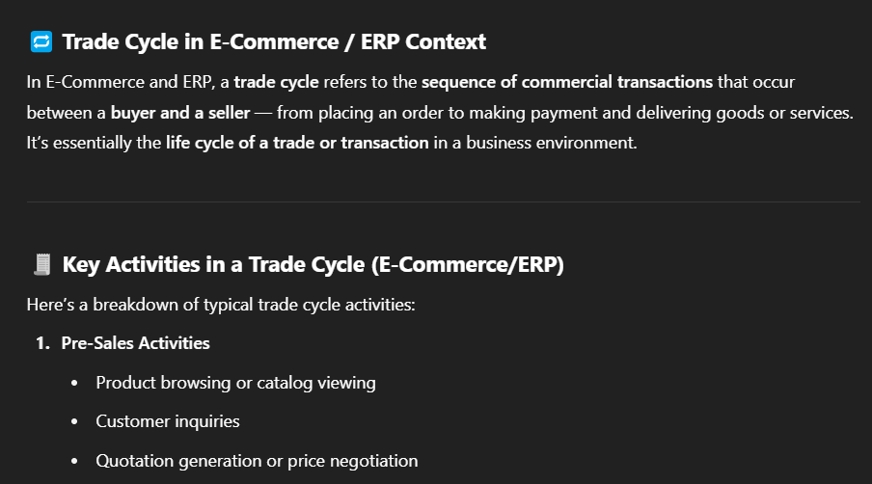

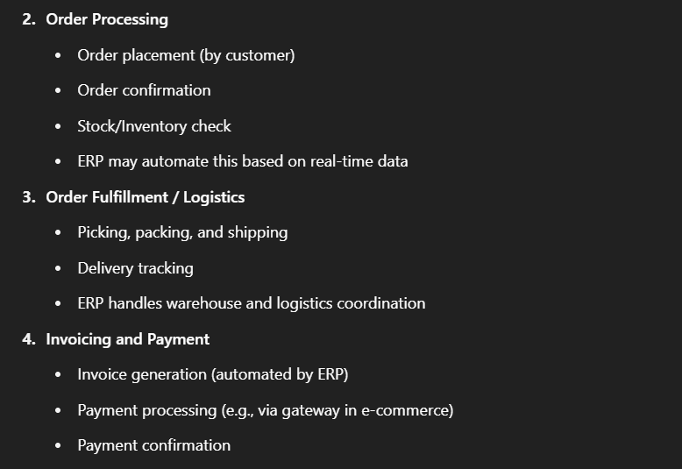

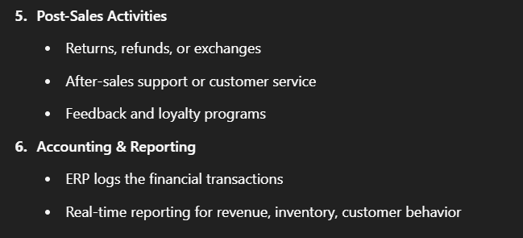

**Q. What is E-Commerce?**

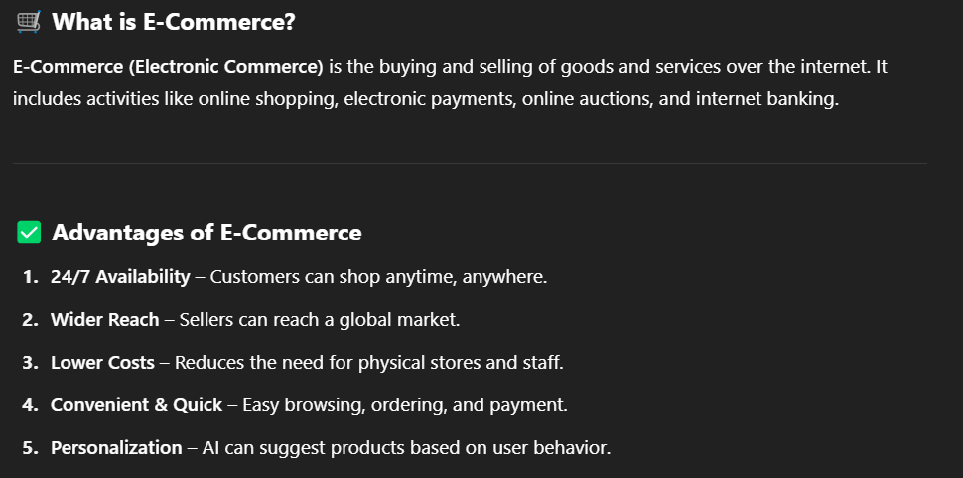

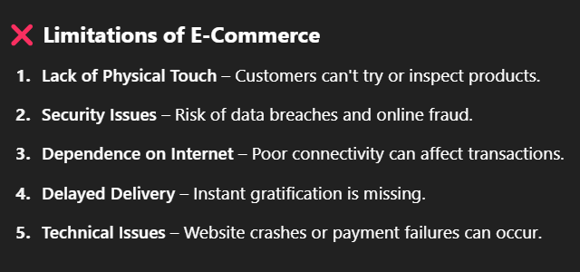

**Q. What is Cyber Crime? Types of Cyber Crime.**

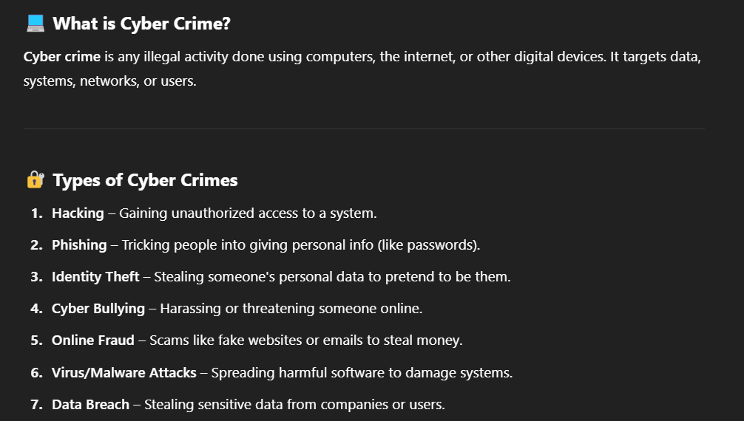

**Q. Internet vs Intranet vs Extranet.**

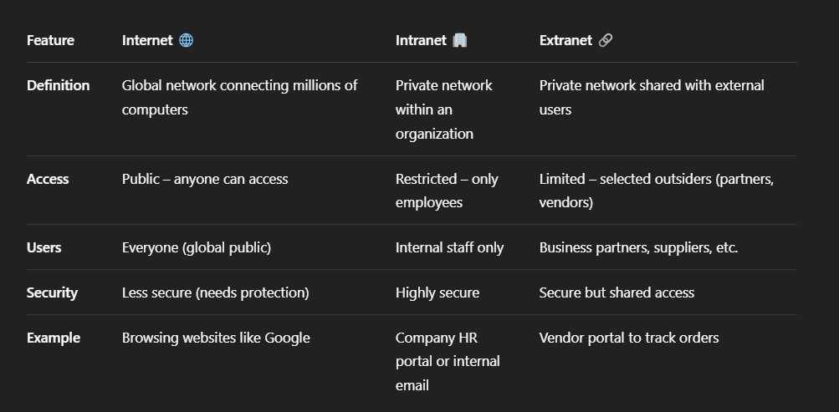

**Q. What is E-Governance? Types of E-Governance.**

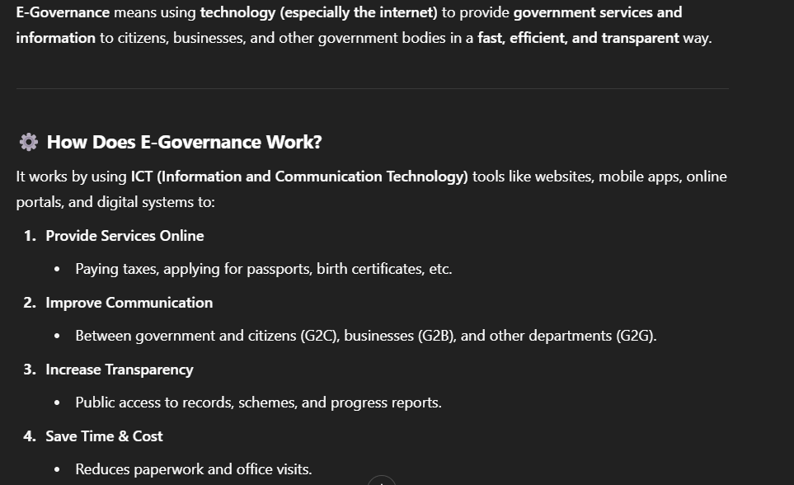

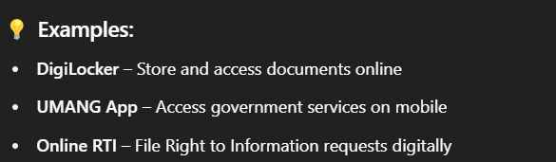

**Q. Different categories of E-Commerce.**

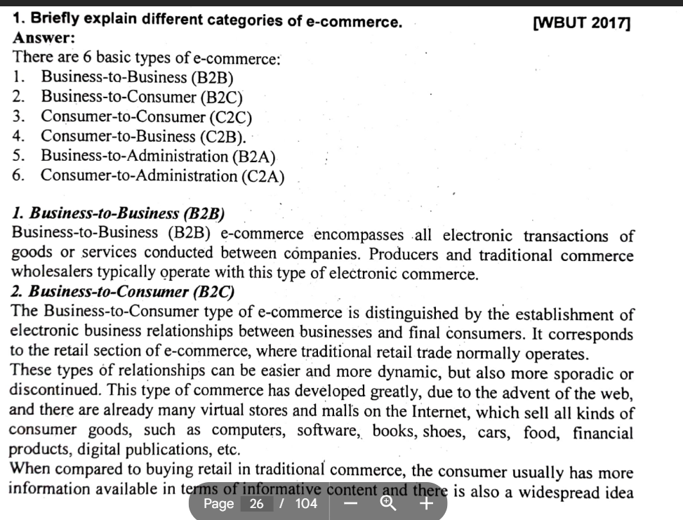

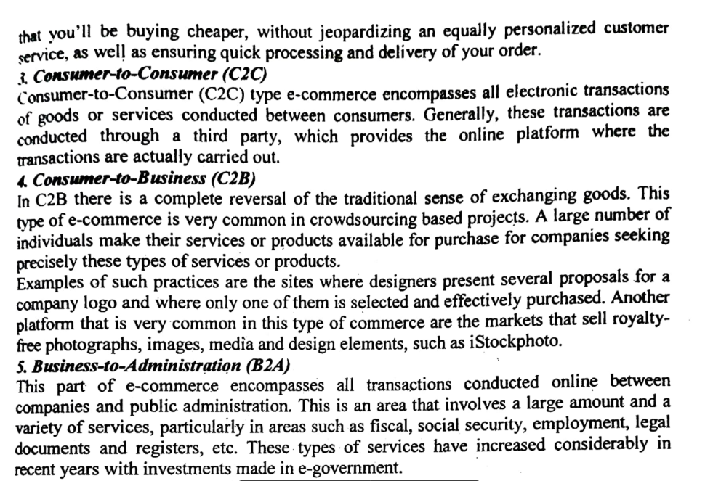

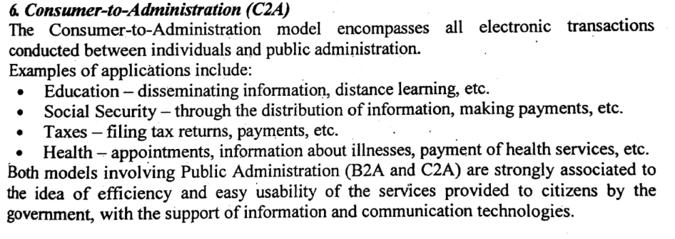

**Q. What is Call Centre? What are the Call Centre equipment’s? Modes of working in Call Centre?**

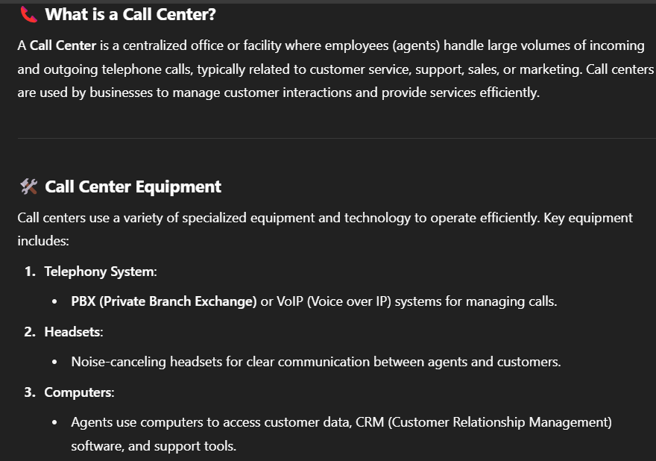

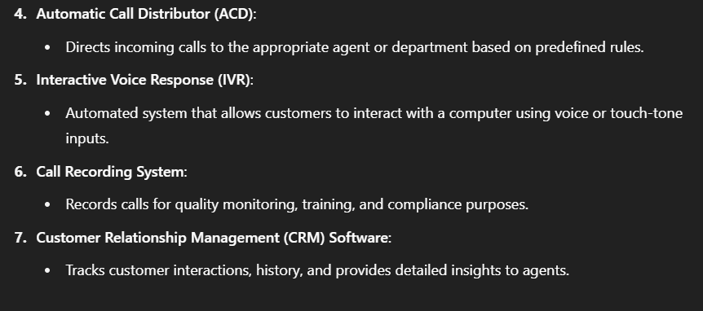

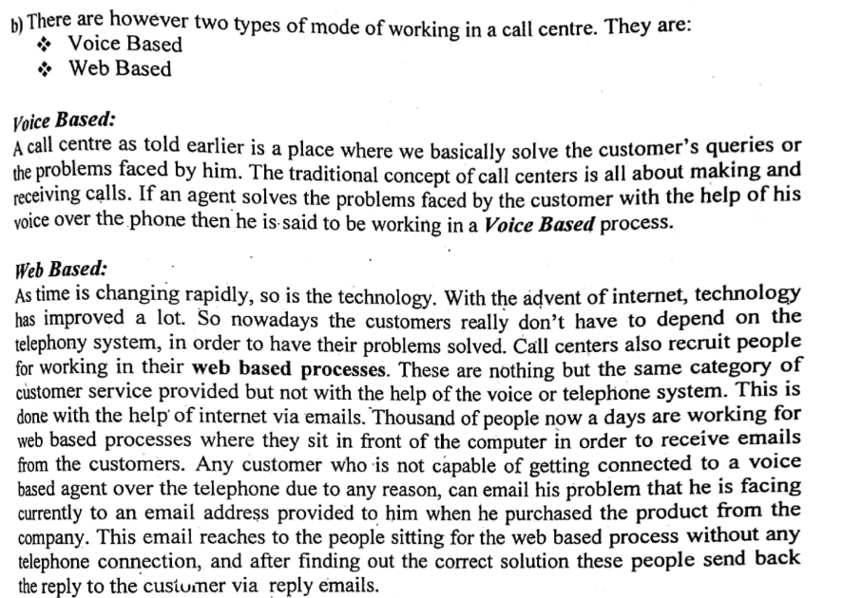

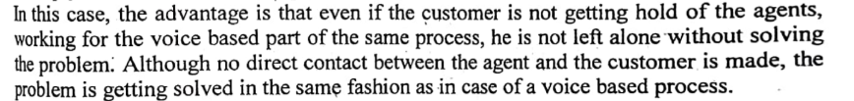

**Q. Customer Premises Equipment.**

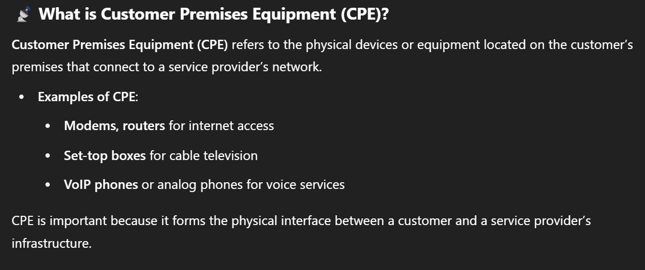

**Q. CRM vs SRM.**

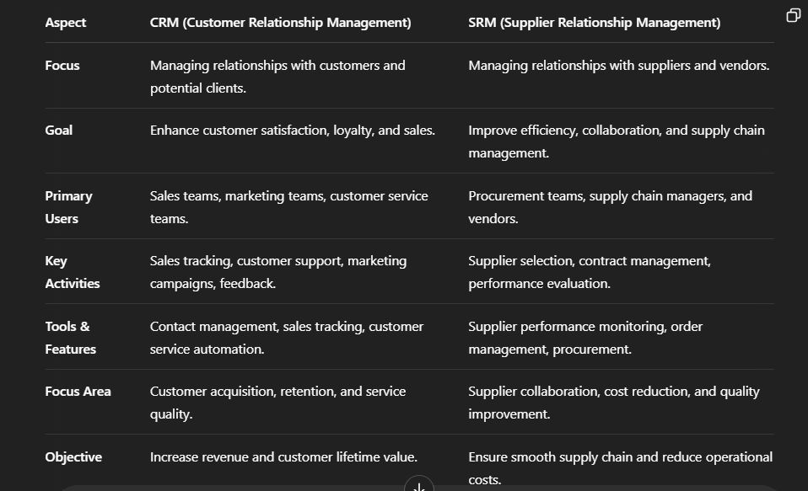

**Q. Flowchart of transaction flow in E-Cash System.**

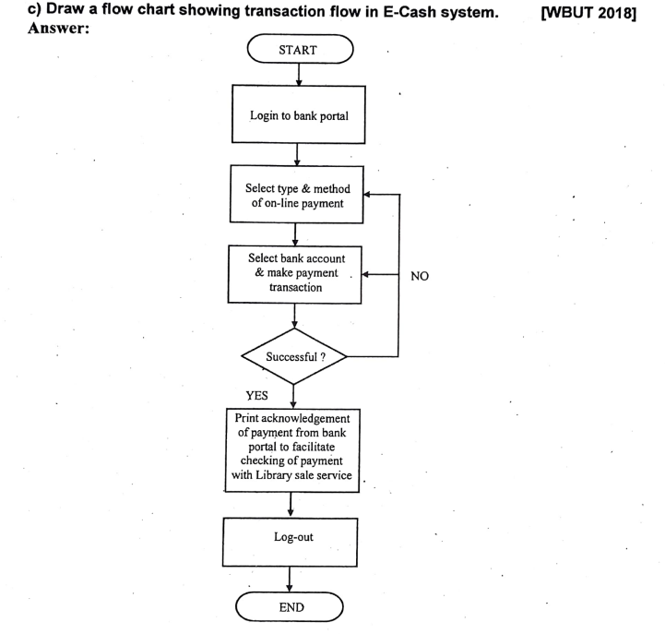

**Q. What is Smart Card.**

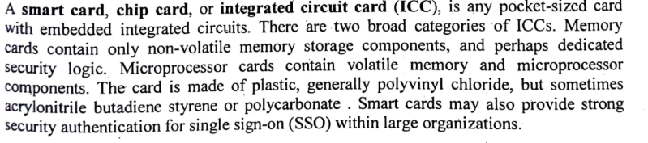

**Q. What is E-Cash? State the advantages and disadvantages of E-Cash.**

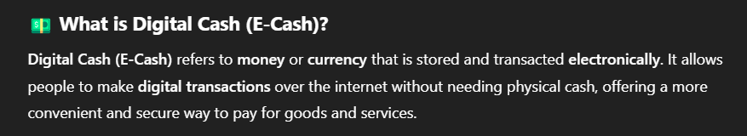

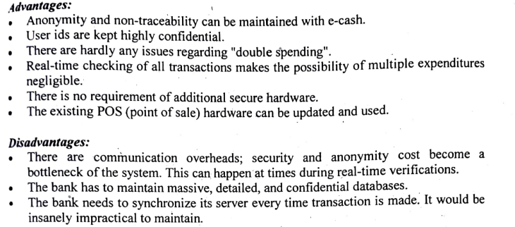

**Q. What is E-Market?**

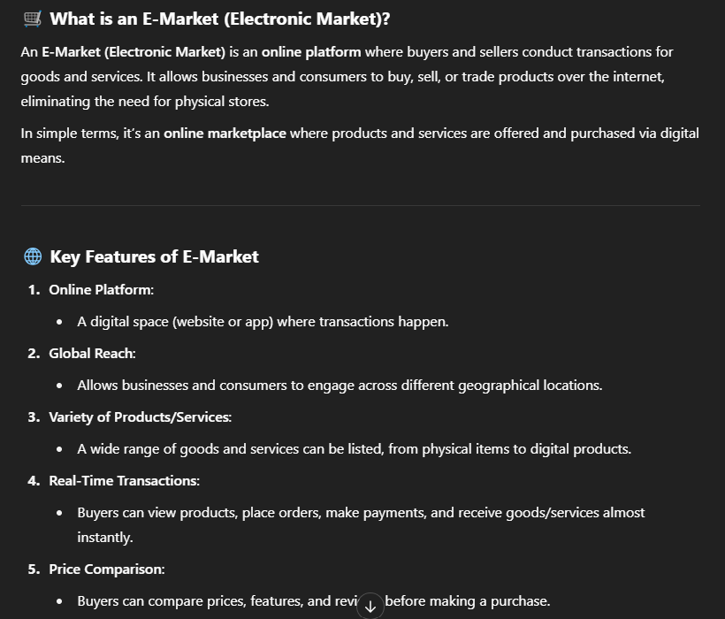

**Q. Discuss about EDI.**

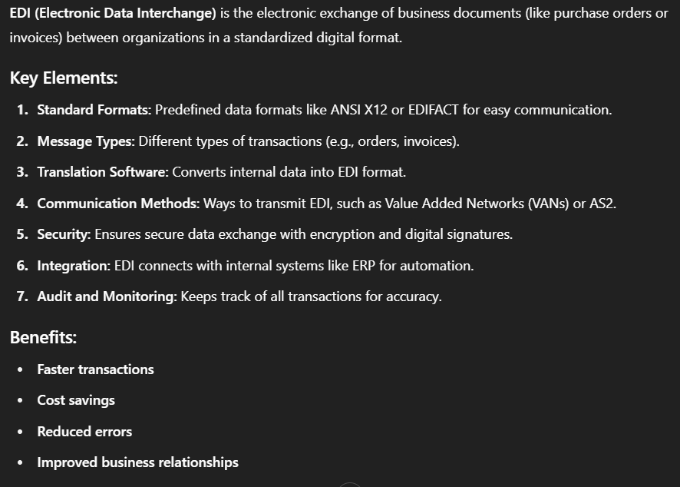

**Q. What is Cryptography?**

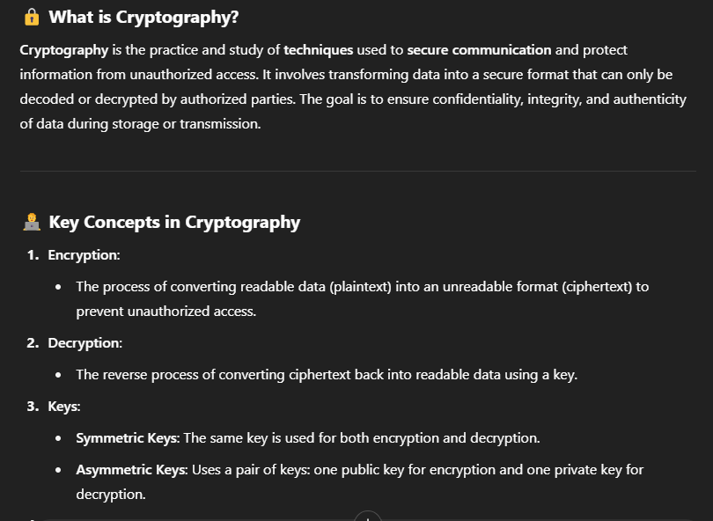

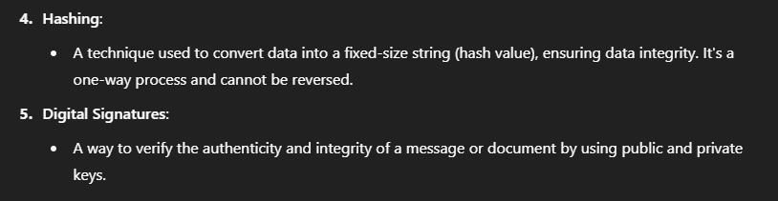

**Q. VAN.**

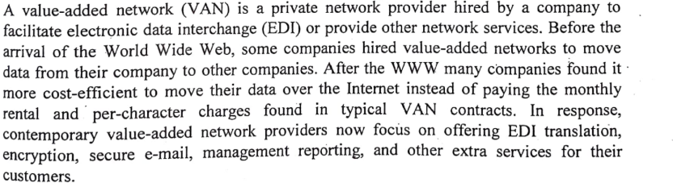

**Q. What is Firewall? State different functions of Firewall.**

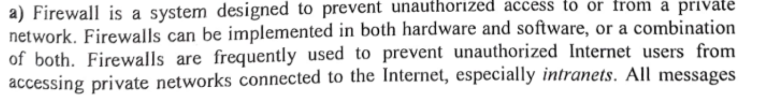

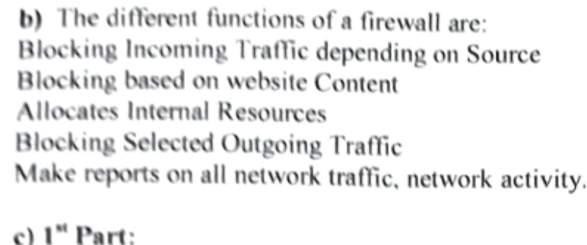

**Q. Digital Signature.**

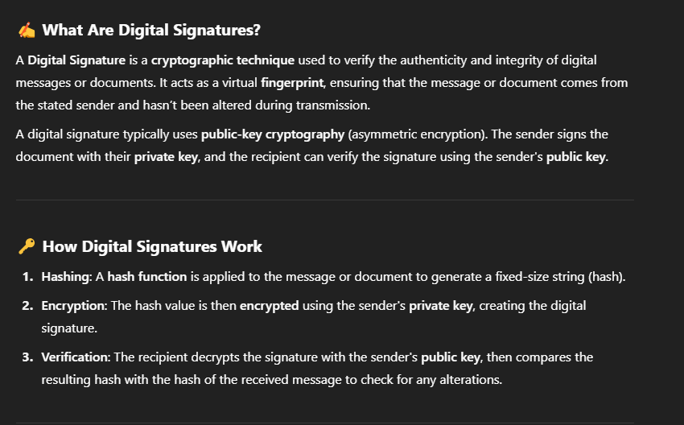\

**Q. What is ERP?**

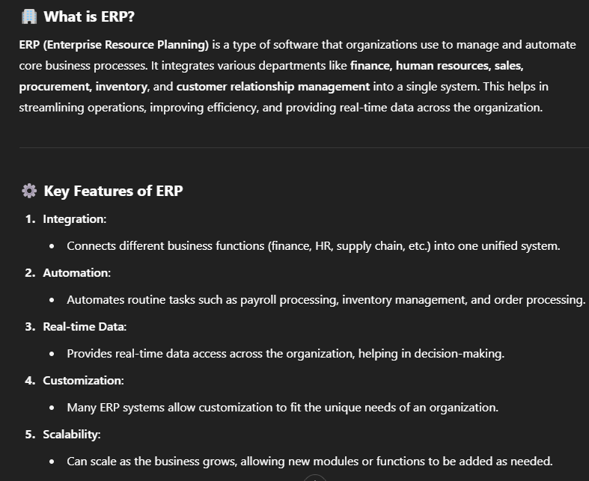

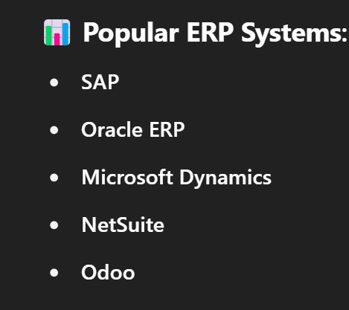

**MCQ’s**

1. **IT Act was passed by the Indian Parliament in the year- 2000**
2. **Types of Trade Cycle in E-Commerce- Three**
3. **ISP Stands for- Internet Service Provider**
4. **E-Bay, Amazon, OLX are examples of- C2C**
5. **SET stands for- Secure Electronic Transaction**
6. **Card Contains a microprocessors and a storage units**
7. **Real estate and Banking are the example of- Vertical Market**
8. **Online Marketing consists of- 4 models**
9. **RSA algorithm deals with- encryption**
10. **EDI Stands for- Electronic Data Interchange**